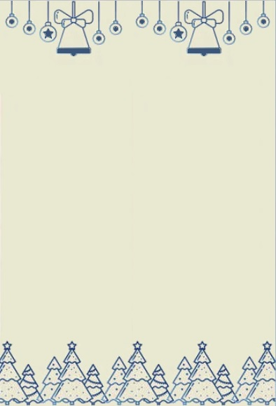

Dear ________________________,

____________________________________________________________________________________________________________________________________________________________________________________________________________________________________________________________________________________________________________________________________________________________________________________________________________________________________________________________________________________________________________________________________________________________________________________________________________________________________________________________________________________________________________________________________________________________________________________________________________________________________________________________________________________________________________________________________________________________________________________________________________________________________________________________________________________________________________________________________

Regards,

________________________________

**MERRY CHRISTMAS**