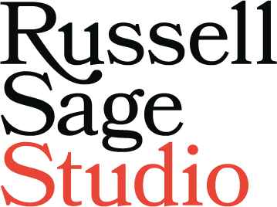

[Full Name] [Company Name] [Address Line 1]
[Address Line 2] [City, County] [Postcode]

[Date]

Dear [Name]

Project Proposal: [INSERT PROJECT DESCRIPTION] (“Project”) at [INSERT SITE DESCRIPTION] (“Site”)

We refer to [REFER TO RELEVANT CORRESPONDENCE] and confirm that you wish to appoint RSS to provide interior design services in connection with the Project at the Site.

We are willing to accept the appointment upon our proposals set out in the following documents:

- this letter and schedules 1 and 2 hereto (“Project Proposal”);

- our standard terms (“the Terms”);

- the contract documents (as listed in schedule 3 hereto) (“Documents”); all of which are attached and together shall form the contract (“Contract”).
Terms referred to in this letter are defined in the Terms, save where the context does not permit.

Countersigning and returning a copy of this Project Proposal letter to us and/or instructing us to begin performing the Services (whether you countersign and return the copy of this letter or not) shall constitute an offer by you to purchase RSS’s Services in accordance with the Project Proposal, on the Terms. The Contract will come into effect when we begin the performance of the Services described in the Project Proposal.

If our Terms are not attached to this letter, they can be viewed and downloaded from our website (https://www.russellsagestudio.co.uk/) or please ask us for a copy of them. We draw your attention to the exclusions and limitations of liability in clause 8 of the Terms. The Terms explain how any conflict or ambiguity between the documents forming the Contract will be addressed.

The Basic Services to be performed by us are set out in the Services Specification in Schedule 2 hereto.

We shall perform the Services in accordance with the Contract in consideration for the Fee to be paid by you (as specified in the Schedule of Fees in Schedule 1 hereto and clause 7 of the Terms). You shall pay us for the Services and perform your obligations in accordance with the Contract in consideration for the supply of Services.

Russell Sage Studio Ltd. | St Michael’s House | 2 Elizabeth Street | London SW1W 9RB | +44 (0) 20 7730 3258 info@russellsagestudio.co.uk | russellsagestudio.co.uk
Company registration No. 06306642, Registered in England & Wales | VAT registration No. 919 2189 05

The Contract will take effect on the Commencement Date.

Please acknowledge receipt of this letter and confirm that you offer to purchase our Services in accordance with the Terms of the Contract by countersigning, dating and returning the enclosed copy of this letter. The Contract will come into effect when we accept your offer by beginning the performance of the Services described in the Project Proposal (whether or not you countersign and return the enclosed copy of this letter.

We look forward to working with you. Should you have any queries in the meantime, please do not hesitate to contact us.

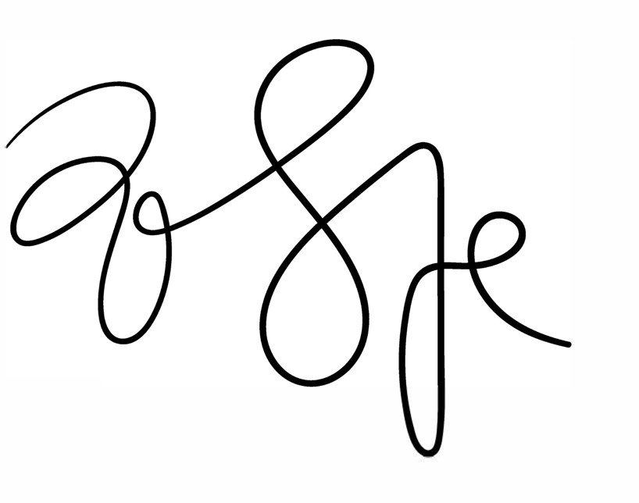
Yours faithfully

Russell Sage
Director for and on behalf of Russell Sage Studio Limited

russell@russellsagestudio.co.uk M: +44 (0) 793 052 8072

Enc.

We, the Client, offer to purchase RSS’s services in accordance with the proposals set out in this letter.

Signed By:

For and on behalf of [the Client], being duly authorised.

Name:

Position:

Date:

russellsagestudio.co.uk V1-01/19 page 2

